Wielding the Double Edged Sword
Using Language with Intention and Purpose in Psychotherapy

Matthieu Villatte matthieu.villatte@gmail.com
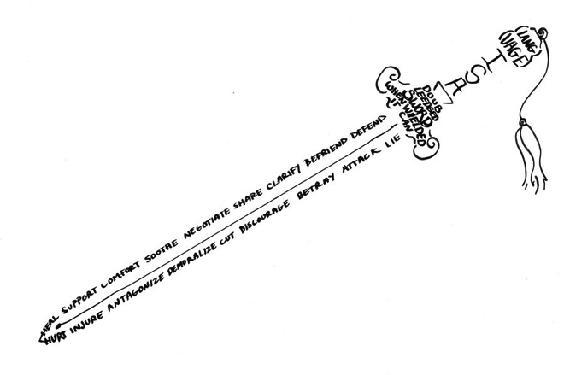

ACBS ACT Training Institute | Brussels | 2014

What are your intentions for this workshop?

Why should therapists care about RFT?

- Language is the learned behavior of building and responding to symbolic relations. Relating is simply responding to one thing in terms of another.
- When we relate objects and events, we learn something about them through the relationship. This dramatically increases the efficiency with which we learn.
- The way we frame objects and events transforms their meaning and impact. Therefore, if we want to change meaning and impact, we can change the way we’re framing.
- Language (symbolic relating) is at the core of all human mental concepts, so therapists are constantly dealing with language whether they like it or not.
- Language is the core of logical reasoning, but the. The logical thing to do is not always the most effective.
- Language works by expansion, not subtraction. When we try to get rid of particular mental content, we are very likely to engage in language that inadvertently strengthens the problematic symbolic relation.
- Although symbolic behavior is based originally on contingency learning, it alters the impact of all forms of learning. This means that direct behavioral principles are not enough to understand human psychology. A theory of symbolic behavior is required.
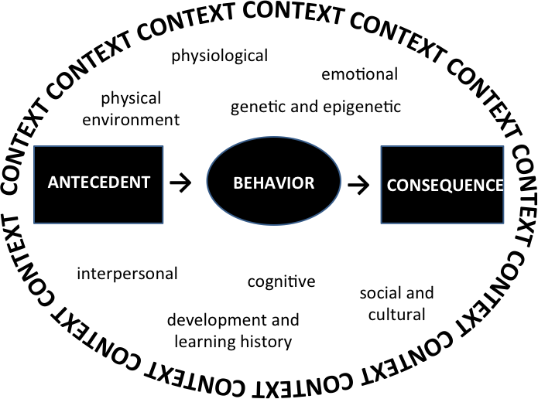
How do we change the meaning and impact of symbolic relations without deleting them?
We alter or add to the context in which they occur, thereby transforming their function.
Self-Reflection:
- What aspects of the context do you and your clients attend to most often?
- What strategies help you and your clients orient to hidden aspects of the context?
- How do you help your clients increase the specificity of their language when talking about context and contingencies?
- What logical strategies are you and your client engaging in that are not working?
- How has a logical explanation of behavior or change strategy interfered with achieving therapy goals?
- What are you and your client adding to the language context that is strengthening problematic meaning or influence?

Suggestions for Deliberate Practice:
When you or your client is stuck, try exploring whether aspects of the context are being ignored or dismissed. How does that impact the conceptualization of the problem, ideas about solutions, motivation, willingness to accept, sense of self-efficacy?

Types of Relational Framing

Equivalence or Coordination: same, like
Distinction: other than, different
Opposition: opposite, incompatible
Comparison: dimensional, more/less, -er, -est
Conditional: If…then, contingencies
Hierarchical: inclusion, is part of, contains
Deictic Framing: I-You, Here-There, Now-Then
Temporal: And then, next, before/after
Analogical: Sets of Relations in Coordination, simile, metaphor

Examples of using language to alter the context
Alter the context with no additional framing
- Word repetition, change tone, volume, or pace of voice, reflective listening, question vs. statement, emphasis, facial expression, gestures, postures

Equivalence/Coordination framing
- “And” instead of “but”
- Alternative evaluations (“wow, that’s great!” “How hard for you, huh?”)
- Invitation to notice other functions (“what else do you notice when you’re anxious?)
- Invitation to add other responses (While you do [dominant response], can you also do [different response]?

Opposition framing
- Irreverence, humor, paradoxes
- Linking a positive to a negative or vice versa

Conditional framing
- Noticing consequences (“What will happened if you do___?”)

Hierarchical framing
- Labeling thoughts as thoughts, feelings as feelings
- “I” container of psychological experiences (“you have the thought that”)

Deictic framing
- Distancing (e.g. If you heard what you said from somebody else, what would you think? What will you think about this thought in 5 years?)

Analogical framing (e.g. metaphors)
- Physicalizing, personifying (e.g. Thoughts as leaves on a stream)
- Set context for curiosity and playfulness (Let’s approach this as a game, a competition, a journey)

Additional Ideas?

Improving Context Sensitivity

Evoke Observation of Experience
- Nonverbal orienting (tactile, visual, auditory cues)
- Verbal orienting (Space and time, Analogy, Perspective taking)

Evoke Description of Experience

Shift from evaluating to describing
- Naming (equivalence) - I feel angry. I hear the clock ticking.
- Labeling (hierarchy) - You’re having the thought … What sensations do you notice?

If the client gets stuck
- Analogical-If it had a size, shape, color? Is it like something else you know? Does it remind you of anything? How is it like X?
- Perspective Taking- If your daughter was experiencing that, how might you help her describe it? What do you think I might be noticing right now?

Get more precise
- Distinction- How is this sensation different than that one? Any feelings we can rule out?
- Comparative- More/less intense? Closer to irritation or rage? Stronger or weaker belief?

Track Functional Relationships

Evoke description of complete contingency (antecedent → response → consequence)
- Conditional - What happens if you do X in Y situation?
- Temporal- What is happening right before you do X?
If the client has difficulty
- Analogies, metaphors, and gestures to help “discover” antecedents/consequences
- Perspective taking –See antecedents/consequences they can’t see here and now
Get more precise
- Comparative- In what situations are you more likely to do X?
- Distinction- In this situation, X happens: In that situation Y happens
Orient to consequences of a response in a given context
  - Conditional- What happened when you did X in Y situation?
  - Correspondence: Did the consequence match your intention/expectation?
  - Comparative- To what degree did the results match your prediction?

Draw out additional consequences
  - And then what? And then? And then?
  - Did anything else happen after doing X? How about in this other area/domain?
  - How did it influence your (thoughts/emotions/motivation/relationships/other goals/future responses)?
  - Any results you didn’t (anticipate/predict/expect)?

Self-reflection and Feedback:
Key Observations:
What worked well:
Areas for improvement:
I have questions about:
I need coaching on:
Suggestions for Deliberate Practice:
- conducting intake, functional assessment, creative hopelessness
- reviewing homework or out of session practice
- debriefing experiential exercises
- client’s target behavior is happening in session
- client over-relies on others for advice, instructions, or feedback
- client’s formulation of a problem is vague or untestable
- client uses vague, nonspecific, or general evaluative language to describe experience

Using Language to Build Values:

Derive values from specific actions and goals
- Hierarchy-What is this action part of? What does it contribute to?
- Conditional-If you achieved that goal, how would your life be improved?
- Comparative- What about this action is more rewarding than that action?
- Coordination- What do all of these actions/goals/interests have in common?

Use opposition/distinction to identify positive and intrinsic reinforcement
- In what ways would your life be better if that burden was removed?
- If nobody knew you got this degree, would you still work toward getting it?
- If no one was watching, what would you be doing?
- What would you be doing if you were not bothered by this stuff?
- If pain was one side of a coin, what do you think you’d find if you flipped it over?

Perspective taking to reconnect with sources of reinforcement
- When you were holding your newborn baby, what did you wish for her?
- When you were a kid, what did you imagine for yourself as an adult?
- If you could time travel and visit yourself in 10 years, what would you want to see?
- If I asked your best friend what matters most to you, what would they say?
- If you were (someone client admires), how would you act differently?
- Take me back to a time in your life when you were most satisfied.

Create sources of reinforcement with conditional questions
- If you had all the time in the world, what would you be doing?
- If you had a billion dollars to donate/invest, where would you put your money?
- What if anything was possible?
- If your life got bigger, what would you have room for?
- If you could write your own epitaph, what would you want it to say?

Practice: Identify values

Key Observations:

What worked well:

Areas for improvement:

I have questions about:

I‘d like feedback on:

Potential Clinical Targets for Deliberate Practice:

- Competing contingencies or goals
- Values “conflicts”
- Lack of purpose or meaning

Normalization/Tracking

Normalization

Coordination framing to provide alternative evaluation
- That’s absolutely normal!
- That must be hard.

Conditional framing to relate experience to context
  - Anyone who grew up around that much violence would be scared in that situation.
  - I can understand why you would think that based on the feedback you get at work.
Deictic framing to establish commonality
  - I would feel that way too if I had lived through that experience.
Tracking
Conditional framing with consequences to assess the effectiveness of responses
- And when you do this, what impact does it have on…?

Comparative framing to assess the effectiveness of alternative options
- On one hand, you can do X and A happens; on the other hand, you can do Y and B happens. Which option works better for you?

Hierarchical framing to connect responses to higher purpose
- Is doing…a way of serving an important part of your life…?

Informative Feedback:
Key Observations:
What worked well:
I have questions about:
I’d like feedback on:
Suggestions for Deliberate Practice:
- When control is a problem
- Client resistance, self-invalidation, shame
- When behaviors are inconsistent with stated goals and values

Developing expert clinical performance
Alas, doing something again and again does not improve performance. Practice must be deliberate, with specific learning objectives, repeated practice, and informative feedback.

Recipe for Deliberate Practice with Feedback:
- Choose a specific learning objective. One at a time works best.
- Formulate a complete tact:
- In (specific context) I will do (specific behavior) in order to (desired outcome).

- Set a practice schedule.
  - How often? How long? For what duration?
  - Remind yourself of #1 before every practice session (this is the deliberate part)

- Track your performance goals.
  - How will you measure improvement? Keep it consistent.
  - Think SMART goals: Get specific and measurable. How will you know if you improve? What will mastery look like?

- Get feedback every time you practice.
  - Track your own performance in a systematic way (quick self-ratings are fine)
  - Client measures (e.g., if you’re working on your skills to target defusion, track client defusion measures)
  - Peer or expert observation (audio, video, live) with specific feedback

Expert Practice Tips:
- Practice is not performance. It will not be pretty. Growth occurs when you stretch just beyond your current capacity, wherever that may be in this moment. Signs of growth: you’re trying something new, noticing what works, AND noticing what doesn’t work.

- Practice the same scenario again and again. Notice subtle differences. Notice what remains the same. Where do your responses seem stuck? Where do you show signs of flexibility?

- If you don’t know what the “right” thing is to do, go with your first response (even if you know it to be “wrong”) and track what works and what doesn’t. Go back to the point that didn’t work and try something different. Track. Compare to the first try. Repeat.

- Try it, tweak it, repeat. Try to resist the urge to start all over again. See if you can get back on track from the moment you noticed yourself off track.
My Deliberate Practice Plan
What skill will I work on? In what situations? How often?

How will I measure my performance? How often will I measure my performance?

What opportunities do I have to practice and get feedback on the issues?

Where can I learn more about these issues?
What opportunities do I have to get peer and/or expert coaching on these issues?
(peer consultation groups, live/skype role plays, written vignettes, video role plays, case consultation)

